Welcome
to
Reception at
Riverdale Primary School

Thank you for your wonderful support so far in preparing the children for full days at school. We hope the information in this booklet will be helpful in settling and supporting your child.

Reception Staff
Mrs Coldwell and Miss Hall

Arriving at school / Home time
A member of staff will be available both at drop off and pick up to answer any little questions you may have or to listen to information you feel is important we know for the day.

Please inform staff of any changes to adults picking up or dropping off so we can pop it in the class diary.

However, these should only be short messages and if you would like to discuss any matters in more depth please make an appointment so we can ensure our full attention and also the safety of the children coming in and out of school.

Morning drop off times 8:45-8.50
Afternoon pick up times 2.45 – 3.00
After this time, when the classroom door is shut you will need to drop off or pick up your child from the main school office.
Autumn Term: Parents can pop belongings on the pegs with children at drop off
Spring Term: Drop children at the classroom door and encourage them to put things on their pegs independently.
Summer Term: Drop children at the outdoor area gate with a member of staff to encourage independence when entering school.

The Outdoor Classroom is often set up ready for the children’s learning so would ask you please to wait for a member of staff to open the gate on a morning and ensure that your children do not use the equipment on their way in or out (including the climbing frame).

Uniform
Children are asked to come in school uniform as follows:
- Green cardigan or jumper
- White or yellow polo shirt / blouse
- Grey or black trousers / skirts
- Black school shoes (Velcro where possible)
It is school policy that if a child comes into school without correct uniform that school provide an alternative until home can get a replacement.

Working in the Outdoor area
The children will be accessing the outdoor classroom all through the year. To ensure they are properly dressed please provide them with:
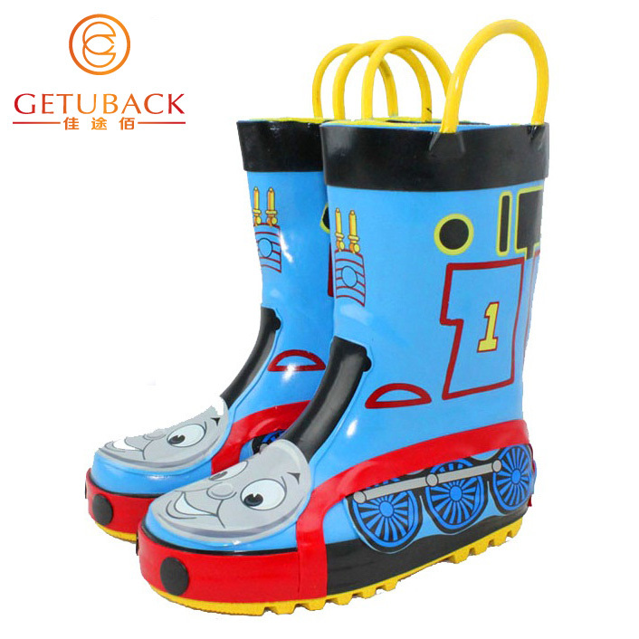
- A practical coat -waterproof and washable
- Wellies
- Gloves & hats / hats and sunscreen

PE Kit
The children will take part in hall sessions and we are beginning to practise getting ourselves undressed and dressed as part of the curriculum.
- Blue/Black shorts
- White T-Shirt
Please bring kits on a Monday and leave them all week as our PE day may be subject to change.

PLEASE MAKE SURE CHILDREN’S UNIFORM AND OUTDOOR CLOTHES ARE LABELLED WITH NAME – SO WE CAN HELP RETURN THEM IF LOST.

Snack – Children are able to access the snack table at any time of the day. Each day of the week there is a different fruit or vegetable available and a drink of milk or water.

As part of the curriculum and a healthy diet, we like to provide additional snack once a week. To do this we ask for the support of parents. In the classroom are money tubs and we ask for a small donation each week to buy food/drinks. We ask the children to come and put the money into the correct tubs to support money recognition. This is a voluntary contribution however and no child will miss out if a donation is not made.

Homework
We are so grateful for all the support that the children receive at home – it is such a crucial part of their learning as a whole. We look forward to this continuing with:
- Reading a short book- with a coloured sticker 3 times a week – this will be the same book for a week to aid consolidation.
- Sharing a longer book with you reading to your child.
Please make sure you sign your child’s reading diary (either for a school book or a book chosen from home). If you are unsure what to do we are always happy to help. At the end of each week children earn points and every multiple of 10 wins a prize from a list the class have made together. At the end of each term children are given an award for reading 3 times every week. Please make sure children bring their book bags everyday.

Children will also be asked to complete other short tasks as part of homework, such as spellings, numbers, letter writing practise or topic linked.

Homework will go out on a Friday as will new books to be returned the following Thursday.

A weekly class letter is available on a Monday (in the classroom window by the classroom door, on facebook, by e-mail and on marvellous me) explaining our focus for the week.

Behaviour
Children are asked to follow the Riverdale Rules. They are encouraged to make the right choices and the focus is always on the positive primarily. Positive behaviour is rewarded with stickers, dips in the treasure basket, star certificates and star of the week.
Children who are not following the Riverdale Rules, follow the traffic light system to ensure it does not impact on their own or others learning.

For a more detailed explanation, please read the school behaviour policy.

Contact information
School: In addition to talking to us face to face, please feel free to contact us by
- telephone through the main school office or by email
rrpjcoldwell@riverdaleprimary.org.uk.
Please be aware that e-mails after 5pm may not be answered until the next school day.
We would ask if you have something to discuss that you approach the children’s key workers in person (Mrs Coldwell or Miss Hall) so all matters can be dealt with privately.

Home: Please ensure your details and the list of authorised people to pick up is kept up to date – if we do not recognise an adult we will not let your child go until we have confirmation from you as they parent. Please bear with us, it is for the children’s safety.

We are really looking forward to the year ahead with you and your child. Our door is open so don’t hesitate to ask any questions you may have.

Thank you in advance for all your support!

