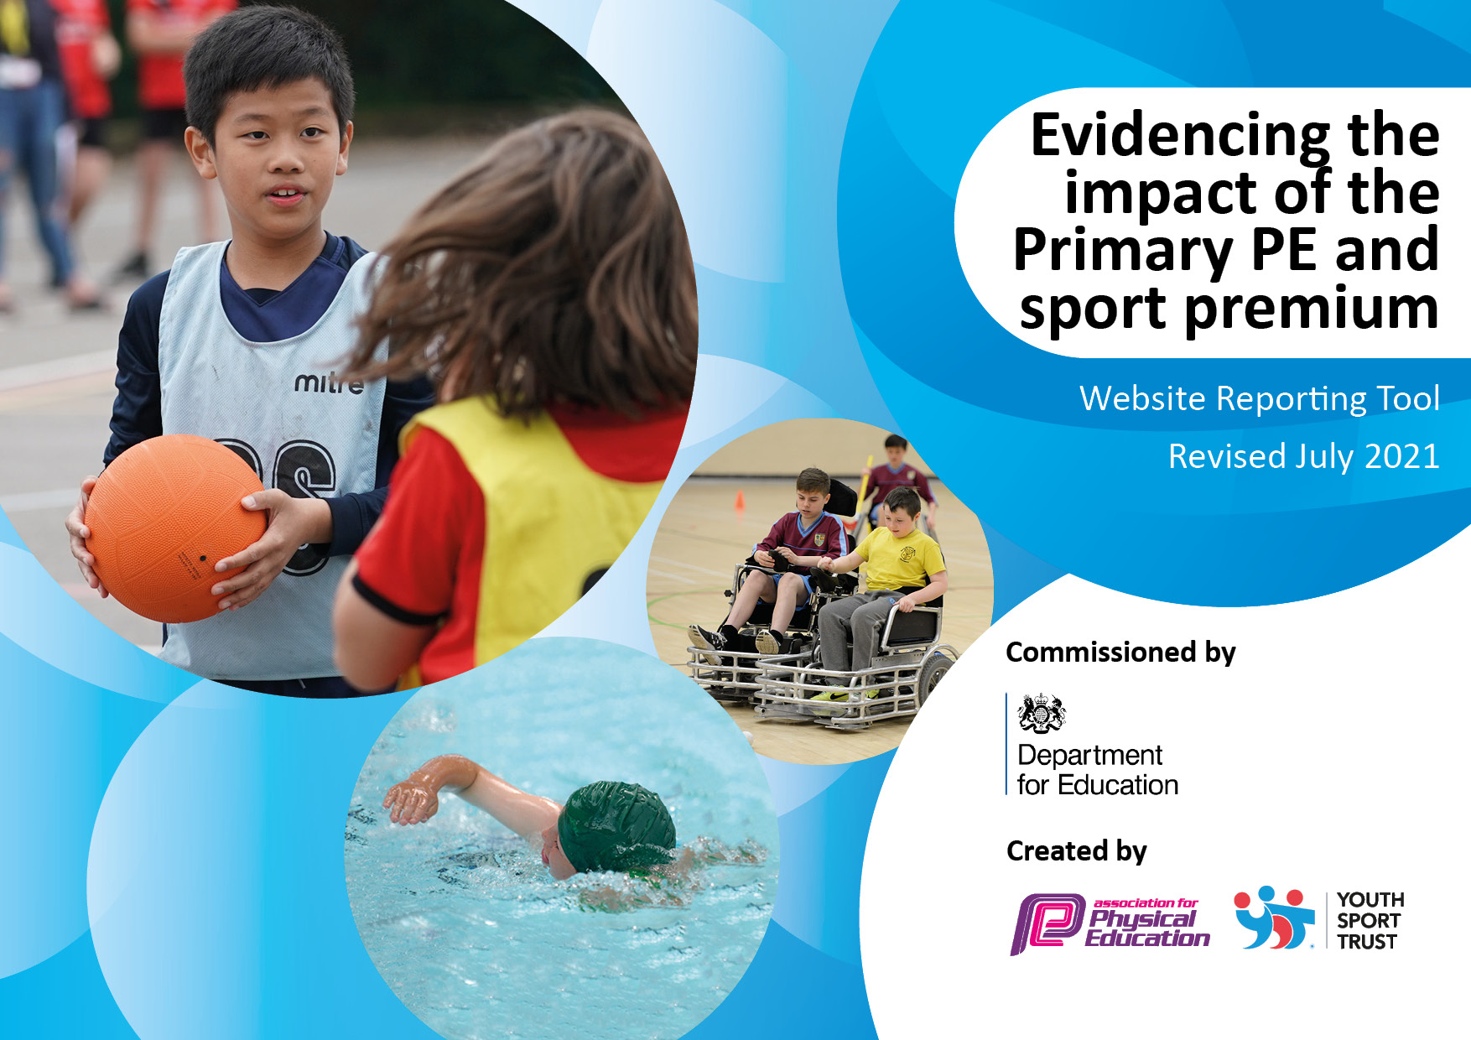
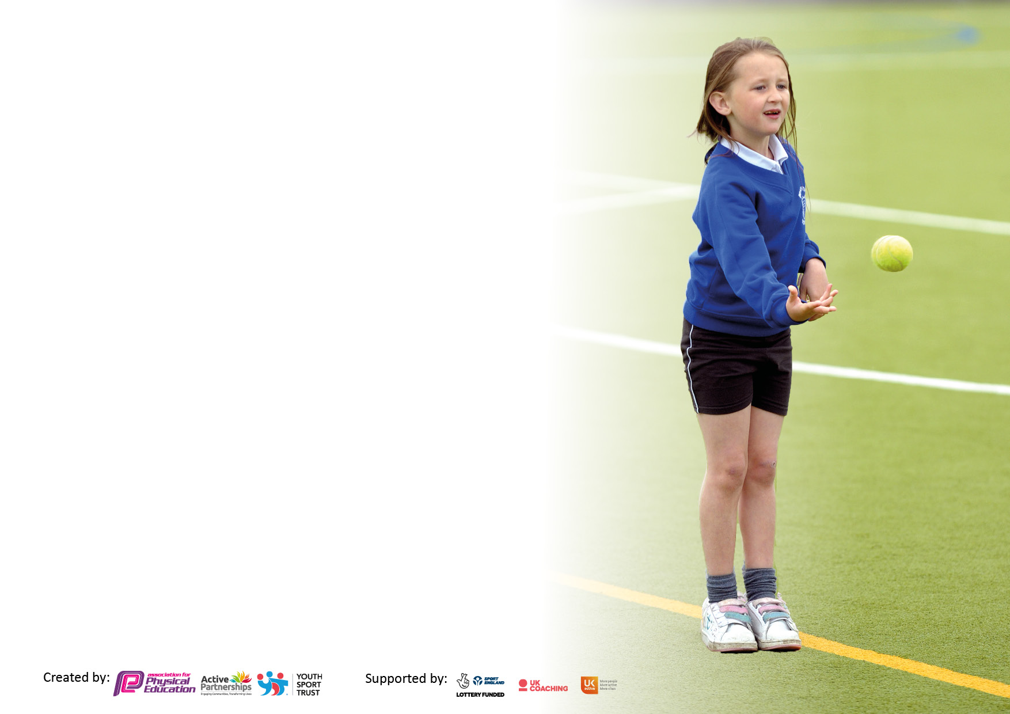

It is important that your grant is used effectively and based on school need. The Education Inspection Framework makes clear there will be a focus on ‘whether leaders and those responsible for governors all understand their respective roles and perform these in a way that enhances the effectiveness of the school’.

Under the Quality of Education Ofsted inspectors consider:
Intent - Curriculum design, coverage and appropriateness
Implementation - Curriculum delivery, Teaching (pedagogy) and Assessment
Impact - Attainment and progress

To assist schools with common transferable language this template has been developed to utilise the same three headings which should make your plans easily transferable between working documents.

Schools must use the funding to make additional and sustainable improvements to the quality of Physical Education, School Sport and Physical Activity (PESSPA) they offer. This means that you should use the Primary PE and sport premium to:

- Develop or add to the PESSPA activities that your school already offer
- Build capacity and capability within the school to ensure that improvements made now will benefit pupils joining the school in future years
- The Primary PE and sport premium should not be used to fund capital spend projects; the school’s budget should fund these.

Please visit gov.uk for the revised DfE guidance including the5 key indicators across which schools should demonstrate an improvement. This document will help you to review your provision and to report your spend. DfE encourages schools to use this template as an effective way of meeting the reporting requirements of the Primary PE and sport premium.

We recommend you start by reflecting on the impact of current provision and reviewing the previous spend.

Schools are required to publish details of how they spend this funding, including any under-spend from 2019/2020, as well as on the impact it has on pupils’ PE and sport participation and attainment. All funding must be spent by 31st July 2022.

We recommend regularly updating the table and publishing it on your website throughout the year. This evidences your ongoing self-evaluation of how you are using the funding to secure maximum, sustainable impact. Final copy must be posted on your website by the end of the academic year and no later than the 31st July 2021. To see an example of how to complete the table please click HERE.

Details with regard to funding
Please complete the table below.

Total amount carried over from 2019/20 | £
Total amount allocated for 2020/21 | £
How much (if any) do you intend to carry over from this total fund into 2021/22? | £
Total amount allocated for 2021/22 | £
Total amount of funding for 2021/22. To be spent and reported on by 31st July 2022. | £
Swimming Data
Please report on your Swimming Data below.

Meeting national curriculum requirements for swimming and water safety.

N.B. Complete this section to your best ability. For example you might have practised safe self-rescue techniques on dry land which you can then transfer to the pool when school swimming restarts.
Due to exceptional circumstances priority should be given to ensuring that pupils can perform safe self rescue even if they do not fully meet the first two requirements of the NC programme of study
What percentage of your current Year 6 cohort swim competently, confidently and proficiently over a distance of at least 25 metres?  N.B. Even though your pupils may swim in another year please report on their attainment on leaving primary school at the end of the summer term 2020.  Please see note above | %
What percentage of your current Year 6 cohort use a range of strokes effectively [for example, front crawl, backstroke and breaststroke]?  Please see note above | %
What percentage of your current Year 6 cohort perform safe self-rescue in different water-based situations? | %
Schools can choose to use the Primary PE and sport premium to provide additional provision for swimming but this must be for activity over and above the national curriculum requirements. Have you used it in this way? | Yes/No

Action Plan and Budget Tracking
Capture your intended annual spend against the 5 key indicators. Clarify the success criteria and evidence of impact that you intend to measure to evaluate for pupils today and for the future.

Academic Year: 2020/21 | Total fund allocated: | Date Updated:
Key indicator 1: The engagement of all pupils in regular physical activity – Chief Medical Officers guidelines recommend that primary school pupils undertake at least 30 minutes of physical activity a day in school |  |  |  | Percentage of total allocation:
 |  |  |  | %
Intent | Implementation |  | Impact
Your school focus should be clear what you want the pupils to know and be able to do and about  what they need to learn and to  consolidate through practice: | Make sure your actions to achieve are linked to your intentions: | Funding allocated: | Evidence of impact: what do pupils now know and what can they now do? What has changed? | Sustainability and suggested next steps:
To ensure that all staff are fully aware of the daily requirement for 60 active minutes and that they fully understand the theory behind it. | PE coordinator to deliver refresher training on the 60 active minutes.  SLT to advocate the importance of keeping children active. | £0 | Staff have the knowledge and understanding of why children should be active and that it links to their educational achievements, health, physical development and mental wellbeing.  Staff have implemented physical activity into their planning.  Pupil voice shows they are having active lessons. | Each year make sure that new staff are trained.  Subject leader to ensure staff do not revert back to sedentary classrooms.  New ideas refreshed to keep up interest for staff and children.
For all children to be fully active at playtime and lunchtimes. | Play equipment purchased to support active playtimes.  Lunchtime supervisors are trained in ideas for playing with children and setting up games at playtime.  The most inactive children are identified by class teachers and lunchtime supervisors. These children are targeted during playtimes to encourage them to have an active playtime. | £500 equipment | Observations at playtime and lunchtime show all children are active.  Equipment is available for the children to encourage play and promote activity. | Throughout the year ensure equipment is monitored and refreshed.  New lunchtime supervisors are trained.  Lists of inactive children are reviewed regularly and updated where necessary.
Promote physical activity at home | General information about the 60 active minutes will be sent home for parents with examples of physical activity they can take part and links to websites such as Cosmic yoga.  All classes set a half termly sports challenge to complete at home by PE coach, class teacher or PE coordinator.  Families are encouraged to take part and send in evidence via Seesaw. | £0 | Increased participation the home challenge.  The time spent on physical activity by the children increases to at least 60 minutes a day. | Start to change the culture within the school community that the school is an ‘active school’.  Promote physical activity opportunities for families outside of school.  Raise the profile of the importance of PE, school sport and physical activity. Ensuring parents and families know that PE is just as important as other subjects.
Ensure children have access to age-appropriate active travel training to encourage children to walk or cycle to school safely. | Year 3 pupils take part in Pedestrian training to learn how to cross the road safely.  Y5 pupils take part in Bikeability Level 1 & 2 training to learn how to ride their bikes safely on the road  Develop an Active Travel plan.  Assembly on Active Travel.  Active travel promotion to parents and families in school newsletters and parent meetings. | Bikeability Training Cost: Part of RESSP Buy in. (Part of £4,500).  Pedestrian Training Cost: £7 per child x 22 children = £154 | The percentage of children either walking or cycling to school will increase.  Children are more awake on a morning.  Less congestion at the school gate for drop off and pick up times.  Children are more confident and competent to ride on roads and cross the roads safely. | Each year the next cohort will be trained.  School staff supporting the instructors from the RESSP fully understand the outcomes and consolidate this learning back in school.  Parents understand the school is an ‘active school’ and the benefits of walking their child to school and spending quality time on a morning.  Balance bikes have been purchased for reception and are used as a weekly PE session.
Key indicator 2: The profile of PESSPA being raised across the school as a tool for whole school improvement |  |  |  | Percentage of total allocation:
 |  |  |  | %
Intent | Implementation |  | Impact
Your school focus should be clear what you want the pupils to know and be able to do and about  what they need to learn and to  consolidate through practice: | Make sure your actions to achieve are linked to your intentions: | Funding allocated: | Evidence of impact: what do pupils now know and what can they now do? What has changed: | Sustainability and suggested next steps:
Develop life skills in pupils. | Integrate Primary My Personal Best into PE.  Subject Leader and Head Teacher attended training.  Subject Leader alongside RESSP delivered whole staff training.  Updated curriculum plan to include life skills for the academic year. | Course Cost: £100  Support from RESSP for staff training: Part of RESSP Buy in. (Part of £4,500). | Explicitly teaching life skills through PE.  The skills are now taught and not caught by accident.  The programme has developed across other curriculum areas.  Children understand what life skills are, what each of them mean and can articulate how developing them can help in PE, in the classroom and outside of school.
Increase the profile of PE and school sport and link skills in PE to other areas of school life. | Spirit of the games values will be implemented with a new focus each half term.  (determination, self belief, honesty, respect, passion, teamwork).  Each lesson the PE coach will identify children who stand out in each area and who show the key skills. Certificates given out in assembly. | £50 printing costs. | Children confidently talk about and recognise the spirit of the games values across all areas of school. | These values will be continued each year and will be refreshed at the end of the year.  Awards evening will be held to honour the children.
Develop leadership skills in children | RESSP trained sports leaders.  A member of staff accompanied the children to the training and now leads the sports leaders team within school.  The children deliver physical activity sessions at break and lunchtimes.  The member of staff in charge meets the leaders once a month to plan activities and to use the group as the student voice for other projects.  The leaders will also support events organised by RESSP. | Leadership Training Cost: Part of RESSP Buy in. (Part of £4,500). | Pupils have increased self-esteem and confidence.  Young leaders benefit from the experience of planning,  organising and delivering a range of sports to a diverse group of children. They became more confident in their leadership qualities.  Staff benefit from training by RESSP so they understand their role back at school with the sports leaders.  A more active school has been achieved by having the ‘mini workforce’ at break and lunchtimes.

Key indicator 3: Increased confidence, knowledge and skills of all staff in teaching PE and sport |  |  |  | Percentage of total allocation:
 |  |  |  | %
Intent | Implementation |  | Impact
Your school focus should be clear | Make sure your actions to | Funding | Evidence of impact: what do | Sustainability and suggested
what you want the pupils to know | achieve are linked to your | allocated: | pupils now know and what | next steps:
and be able to do and about | intentions: |  | can they now do? What has
what they need to learn and to |  |  | Changed?
consolidate through practice:
Ensure that the new sports teacher is fully confident in all areas of PE and school sports. | Identify the key areas that he needs support with.  Bring in external support via RESSP and Lesley Shepherd. Carry out model lessons and team teach.  Regular catch ups between sports coach and the head teacher and the PE coordinator to check in.  CPD provided in specific areas via RESSP training programme. | Course Cost: Part of RESSP buy in (Part of £4,500).  Lesley Shepherd: | Sports teacher is confident and competent.  Sports teacher has identified his strengths and weaknesses so the RESSP team or subject leader can support him in the future.  Lessons are of high quality and coaching is having an impact on children’s skills. | Continue to provide training and support where necessary in all areas of PE.  Keep a check on the CPD offer from the RESSP to ensure up to date training.
The new sports teacher has high quality PE resources and materials to support planning. | Regularly review the sports teachers lesson plans and use of lesson resources and materials to ensure high quality lessons are being taught. | £0 | Lessons and resources are of high quality and allowing the children to receive high quality, impactful lessons. | Review lessons support materials regularly and take advice from the
Key indicator 4: Broader experience of a range of sports and activities offered to all pupils |  |  |  | Percentage of total allocation:
Intent | Implementation |  | Impact
Your school focus should be clear | Make sure your actions to | Funding | Evidence of impact: what do | Sustainability and suggested
what you want the pupils to know | achieve are linked to your | allocated: | pupils now know and what | next steps:
and be able to do and about | intentions: |  | can they now do? What has
what they need to learn and to |  |  | changed?
consolidate through practice:
A broad and balanced curriculum is offered to all children across school. | Review the curriculum offer across all year groups to ensure it provides all children with a range of activities and sports.  Ensure pupil’s voice is heard by carrying out a survey and using the results to support the curriculum offer where appropriate and possible. | £0 | All children will receive lessons in all areas of school sport and PE lessons will be varied throughout the year.  Children will be happy with the range of activities offered in PE and across school.  Progression will be clear throughout the different areas. | Curriculum map has been reviewed and adapted.  Ensure that this happens annually and children’s voice is taken into account.
The children are given the opportunity to experience a range of sports and physical activities outside of the school’s traditional offer. | The sports coach will attend Quidditch training and will be provided with the opportunity to fit this into the curriculum map in Y6.  Themed weeks will be held throughout the year and adapted for each year group e.g. Commonwealth games and  Paralympics.  In these weeks the children will experience sports that are held at these events e.g. curling. | £75 for Mr Skipsey to attend Quidditch course | Theme weeks will be carried out and the children will be excited and enthused by these sports.  Quidditch will become part of the Y6 curriculum | Review at the start of the academic year which themes we can incorporate into the curriculum.  Continue to research and develop new sports and activities for the children to participate in.
To ensure that all children and young people enjoy some form of sport or physical activity | Take part in RESSP festivals and development days both virtual and in person.  Multi-sports club for Y3 & 4 pupils, playing fun activities each week.  Dance club for KS2  Judo and cricket taster sessions.  Athlete for schools days. | Cost of Judo and cricket Sessions: FREE  Festival & Development Days Cost: Part of RESSP buy in (Part of £4,500). | The children are engaged more in PE and after school clubs due to the wider and broader selection of activities | Continue to enter children into sports events and festivals.  Ensure thought goes into which children are selected for which event.  Follow up work to every event to ensure maximum impact.

Key indicator 5: Increased participation in competitive sport |  |  |  | Percentage of total allocation:
 |  |  |  | %
Intent | Implementation |  | Impact
Your school focus should be clear | Make sure your actions to | Funding | Evidence of impact: what do | Sustainability and suggested
what you want the pupils to know | achieve are linked to your | allocated: | pupils now know and what | next steps:
and be able to do and about | intentions: |  | can they now do? What has
what they need to learn and to |  |  | Changed?
consolidate through practice:
Ensure that every pupil, by the time they reach Y6, has represented their school in a sporting activity | Enter into RESSP competitions and festivals.  Ensure children are entered into appropriate levels of competition to suit their individual motivation, competence and confidence levels.  Keep a track of which competitions and festivals every child has attended.  Celebrate ALL participation achievements, not just the winners. | Competition Cost: Part of RESSP buy in (Part of £4,500). | Pupils’ skills developed through the experience and some developed an interest in a new activity.  Pupils have a sense of belonging to their school as they represented the school.  Pupils have improved their confidence, competence, motivation, knowledge and understanding in various sports and activities.  The children have had fun!  Staff have benefitted from the professional development opportunities through attending events and learning from the deliverers.  The events have been used as a carrot for good behaviour in school and we have seen a significant improvement. | Ensure that all children are appropriately prepared for the competition they are attending to further increase their physical literacy levels particularly their confidence and motivation levels.  Reinforce the Spirit of the Games values that RESSP are aiming to develop in our children: Honesty, Passion, Determination, Self-Belief, Respect and Teamwork.
Develop intra competitions across the curriculum and link to the house system. | Every child in KS1 and KS2 will take part in at least one intra competition this year.  The competitions will link to the house point system. | £0 | Children have had fun.  They have experienced competition within school and in a comfortable and safe environment.  The link between the house system and PE have helped to develop the whole school approach of PE and school sport. | Ensure that all children are taking part in intra competitions through record keeping.  Develop the range of the intra competitions each year so the children do not get bored.

Signed off by
Head Teacher:
Date:
Subject Leader: | Mrs S Rathbone
Date: | 30.9.21
Governor:
Date:

